ROCK FAMILIES

There are three families of rocks - igneous, sedimentary and metamorphic.

IGNEOUS ROCK

More than 80 % of the Earth’s crust is made up of igneous rocks.

These rocks were formed by cooling molten rock material, either within the crust or after it had poured out onto the surface from volcanoes.

Within the Earth, the molten rock is called magma. It is formed by the high temperatures and pressures.

The great pressure may force the magma up through cracks in the crust, resulting in a lava flow and the formation of volcanoes.

Igneous rock is classified into two groups:

Intrusive (volcanic) - formed by magma cooling below the surface. These rocks are seen
only after erosion has removed the surrounding rock.
e.g. granite, dolerite.

Extrusive (plutonic) - formed by lava cooling on the surface.
e.g. basalt, pumice.

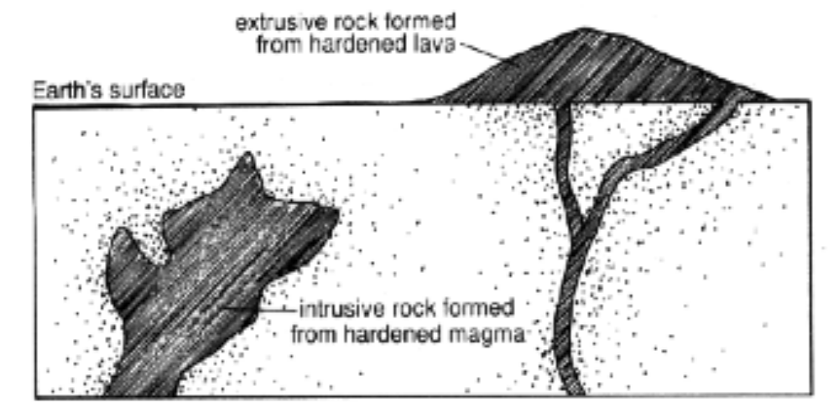

Igneous rocks contain crystals whose size depends on the rate of cooling.

SLOW COOLING - produces large crystals.

FAST COOLING - produces small crystals.

Therefore, intrusive rocks should produce large crystals as they cool slowly underground, while extrusive rocks should have smaller crystals due to their quicker cooling on the surface.
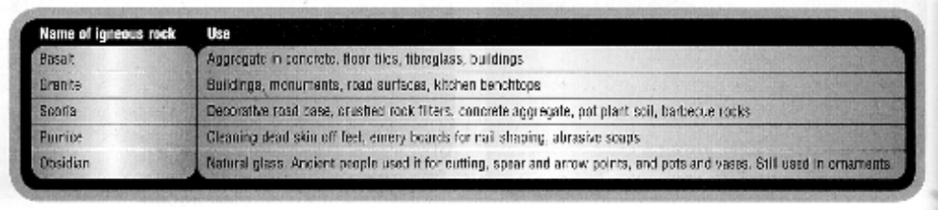

SEDIMENTARY ROCK

This is formed by small fragments of rocks (sediments) building up in layers over millions of years.

The fragments are closely packed and are cemented together by substances such as calcium carbonate.

Water and wind are constantly wearing away (eroding or weathering) the Earth’s crust and moving the fragments from one place to another.

Over time, huge amounts of eroded material are carried into lakes and oceans where they eventually settle to the bottom.

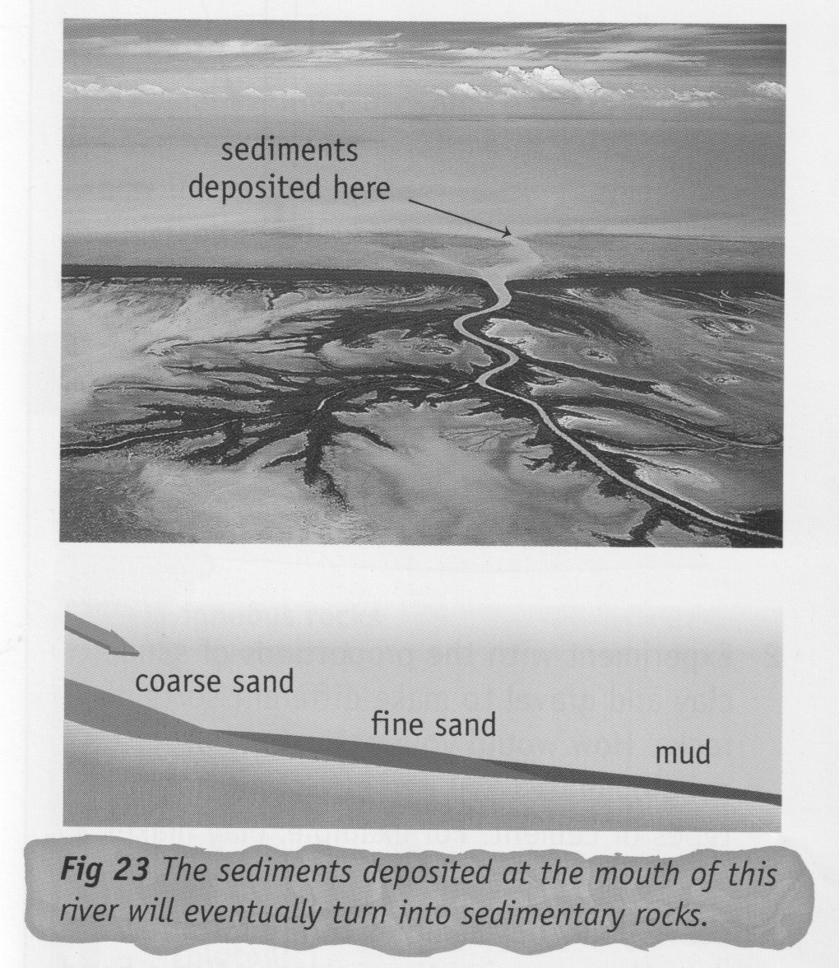

As the material builds up, layers or beds are formed. These are squeezed together by the weight of the sediment and water on top of them to form the sedimentary rock. Some rocks are cemented together by chemical action.

e.g. Mudstone/shale is formed by fine grains of clay.
Sandstone is formed by granules of sand, mainly quartz.
Conglomerates are round stones that are cemented together.
Fossils (the remains of trapped plants and animals) are often found in sedimentary rock.

The grains that make up sedimentary rocks show the effects of erosion. They may be smooth and rounded - the particles have been carried a long way. The greater the distance carried, the rounder the grains become.

e.g. Conglomerates have well-rounded grains.
Breccia has angular grains, indicating that they have not moved far.

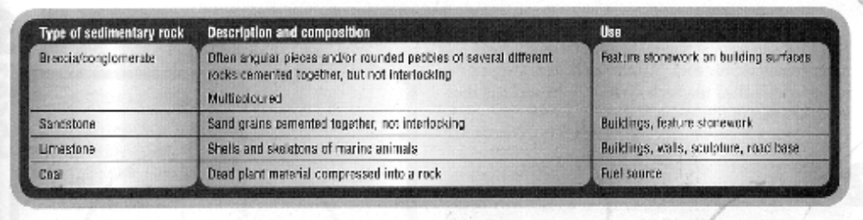

METAMORPHIC ROCK

This is igneous or sedimentary rock that has been changed by the action of intense heat and pressure below the Earth’s surface.

Metamorphic rocks are rocks whose original forms have changed.

New minerals may be formed and the rock generally becomes harder.

e.g. Shale is easily broken apart but slate (its metamorphic form) is very hard and dense.

Metamorphic rock may be formed when intruding hot magma heats and squeezes the surrounding layers of sedimentary rock.

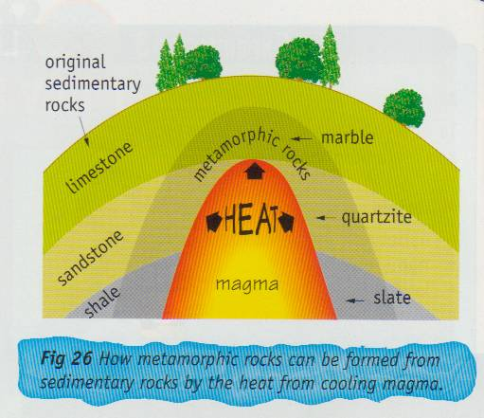

Some metamorphic rocks look very different to their “parent” rock.

e.g. Marble is the metamorphic form of limestone.

Although these two are very different in appearance, they still have some common characteristics.

e.g. They both react in acid to form CO₂ gas. They have the same hardness (3.0 on the
Moh scale).

